­­Mercedes-Benz

W209

Soft Top

Operation

Diagnostic Aid

**Hydraulic Parts**

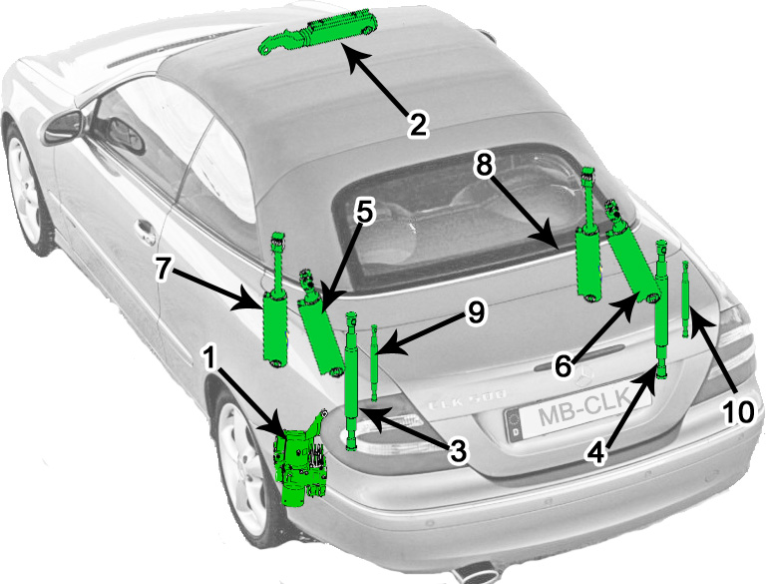

|  |  |
| --- | --- |
| Cylinder Designation | Name of Cylinder |
| 1 | Hydraulic Pump - A2098000648 |
| 2 | Front Lock Cylinder - A2098001172 |
| 3 | Left Soft Top Compartment Cover Lid Cylinder - A2098001272 |
| 4 | Right Soft Top Compartment Cver Lid Cylinder - A2098001272 |
| 5 | Left Bow Cylinder - A2098000972 |
| 6 | Right Bow Cylinder - A2098000972 |
| 7 | Left Top Actuation Cylinder - A2098000772 |
| 8 | Right Top Actuation Cylinder - A2098000872 |
| 9 | Left Trunk Lid Cylinder (with trunk closer option 881) - A2098001472 |
| 10 | Right Trunk Lid Cylinder (with trunk closer option 881) - A2098001472 |

**Electrical Parts**

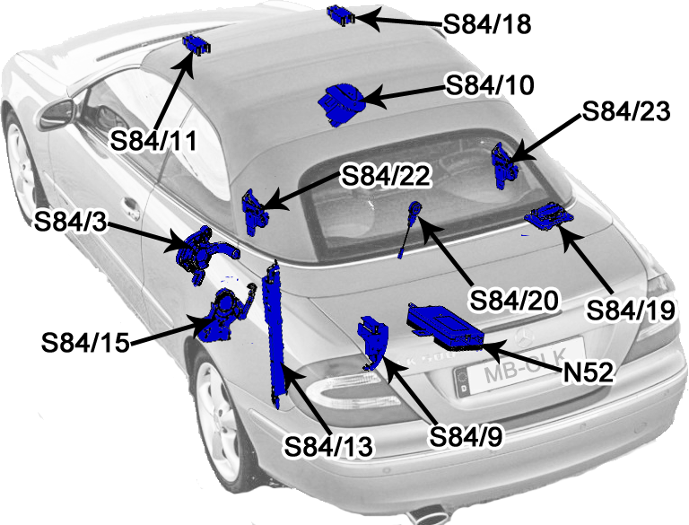

|  |  |
| --- | --- |
| Switch Designation | Name of Switch |
| S84/3 | Soft Top Open Limit Switch - A2098202010 |
| S84/9 | Trunk Partition Limit Switch - A2098209310 |
| S84/10 | Soft Top Actuation Switch (dual Position) - A2098203110 |
| S84/11 | Soft Top Locked Limit Switch - A2098201151 |
| S84/13 | Compartment Cover Lid Open/Close Limit Switch (dual position) - A2098201810 |
| S84/15 | Bow Up/Down Limit Switch (dual position) - A2098202110 |
| S84/18 | Soft Top in Catch Position Limit Switch - A2098202410 |
| S84/19 | Bow Locked Limit Switch - A2098201710 |
| S84/20 | Ski Bag Limit Switch (optional with ski bag) - A2098209410 |
| S84/22 | Compartment Cover Lid in Catch Position Limit Switch, Left - A2098201910 |
| S84/23 | Compartment Cover Lid in Catch Position Limit Switch, Right - A2098201910 |
| N52 | Soft Top Actuation Control Module (part no. varies) |

* Note that S84/20 only exists if the car has the options ski bag pass-through in the rear seatback.
* S814/13 has two positions: “s1” indicated that the lid is fully closed, “s2” indicates that it is fully open.
* S84/23 may not exist on early models (pre-MY2005 facelift). This was added and is wired in series with S84/13s1 so that both switches must be activated in order for the compartment cover lid to be recognized in the “catch” position.
* The “catch” position of the soft top means that it has reached the windshield, but is not necessarily locked in place.
* The “catch” position of the compartment cover lid means that the front edge of the lid has lowered and locked into the C-shaped hooks behind the rear seat headrests, but the trailing edge of the lid may not yet be fully lowered.

**Opening Sequence**

|  |  |
| --- | --- |
|  | STAGE 0: S84/10 is continuously activated. S84/9 and S84/20 verify that the trunk partition and optional ski bag are closed. Side windows lower. |
|  | STAGE 1: Cylinders 3 and 4 are activated to raise the compartment cover lid until switch S84/19 registers that the bow has released from the lid and switch S84/13 registers that the lid is no longer in the closed position. |
|  | STAGE 2: Cylinder 2 is activated to release the front latch. Switch S84/11 registers that the roof is no longer locked, and S84/18 registers that the roof is still in the catch position. |
|  | STAGE 3: Cylinders 5 and 6 are activated to raise the rear glass (bow). Switch S84/15 registers that the bow is now in the fully upright position |
|  | STAGE 4: Cylinders 3 and 4 are activated to raise the compartment cover lid fully. Switch S84/13 registers that the compartment cover lid is in the fully raised position. |
|  | STAGE 5: Cylinders 5 and 6 are activated to lower the bow (rear glass). Switch S84/15 registers that the bow is lowered. |
|  | STAGE 6: Cylinders 7 and 8 are activated to begin lowering the top into the trunk. Switch S84/18 registers that the roof is no longer n the catch position. As the lop lowers, the flaps are mechanically connected to the mechanism and are extended. |
|  | STAGE 7: Cylinders 7 and 8 continue to lower the top fully into the trunk. Switch S84/3 registers that the top is fully lowered. |
|  | STAGE 8: Cylinders 3 and 4 are activated to lower the compartment cover lid. Switches S84/22 and S84/23 register that the compartment lid is in the catch position. |
|  | STAGE 9: Cylinders 3 and 4 are activated to pull the compartment cover lid fully closed. Switch S84/13 registers that the compartment cover lid is fully closed. Opening Sequence is completed. |

**Closing Sequence**

|  |  |
| --- | --- |
|  | STAGE 0: S84/10 is continuously activated. |
|  | STAGE 1: Cylinders 3 and 4 are activated to fully raise the compartment cover lid Switch S84/13 registers that the compart cover lid is fully raised |
|  | STAGE 2: Cylinders 7 and 8 are activated to raise the soft top from the trunk. Switch S84/3 registers that the soft top is no longer lowered. As the lop lowers, the flaps are mechanically connected to the mechanism and are extended. |
|  | STAGE 3: Switch S84/18 registers that the soft top has reached the windshield. |
|  | STAGE 4: Cylinders 5 and 6 are activated to raise the bow (rear glass). Switch S84/15 registers that the bow is in the fully raised position. |
|  | STAGE 5: Cylinder 2 is activated to lock the roof onto the windshield. Switch S84/11 registers that the roof is locked to the windshield. |
|  | STAGE 6: Cylinders 3 and 4 are activated to lower the compartment cover lid. Switch S84/13 registers that the lid is no longer in the fully raised position. The lid continues to lower until switches S84/22 and S84/23 register that the compartment cover lid is in the catch position |
|  | STAGE 7: Cylinders 5 and 6 are activated to lower the bow (rear glass). Switch S84/15 registers that the bow is no longer in the fully raised position as the bow lowers. Switch S85/14 registers that the bow is in the lowered position |
|  | STAGE 8: Cylinders 3 and 4 are activated to fully close the compartment cover lid. Switch S84/19 registers that the bow is locked to the lid. Switch S84/13 registers that the compartment cover lid is fully closed |
|  | STAGE 9: Side windows raise. Closing sequence is completed |

**Revision History**

|  |  |  |
| --- | --- | --- |
| Version | Date | Notes |
| 1.0 | 2017-08-05 | Initial document creation |
| 1.1 | 2017-08-06 | Formatted open/close stages into tabular format, added diagrams showing component positions, added page numbers |
| 1.2 | 2017-08-06 | Corrections based on feedback from forum member Keyhole, added notes section to electrical components list, added revision history |
| 1.3 | 2017-08-30 | Modified order of open and close to correct for when the front windshield latch is operated. |